Repositories

This document establishes a standardized approach for designing and implementing repositories within the 63BITS application ecosystem. It defines folder and file structure, outlines rules for repository creation, and explains how repositories are integrated and wired into the overall architecture.
The goal is to ensure consistency, maintainability, and scalability across the codebase, enabling development teams to follow a unified pattern when accessing and managing data.
Repositories, in 63BITS applications, are designed specifically for calling database functions and stored procedures using ORMs like EF Core and return results via DTO C# records or simple values.

Repository Directory/File Structure Rule
Directory Location
All repositories are implemented in SixtyThreeBits.Core/Infrastructure/Repositories.

Base Repository
The Base subdirectory houses RepositoryBase, the base class inherited by all repository classes.

Repository Directory Naming Rule
Each repository resides in its own subdirectory, named to logically match the repository's purpose usually (but not always) matching up with database Table name.

Repository File and Class Naming Rule
The repository file name and class name must be the logical entity name, usually (but not always) matching up with database Table name, followed by “Repository”.
Each repository class must reside in its own file — one class per file.

Repository-Specific DTO File and C# Record Naming Rule
All DTO classes specific to a repository are located in a DTO subdirectory within that repository's directory.
DTO file name and C# record name must match up with the SQL stored procedure or function name, followed by DTO.
The only exception is C# record for GetSingle, which must match up with table name in singular form, followed by “DTO”.
Repository-Specific DTO Requirements
All DTOs must
- Be implemented as public C# record
- Explicitly declare properties using { get; init; } syntax
- Have namespace SixtyThreeBits.Core.Infrastructure.Repositories

Example
- Database Table: Products
- Directory: Products
- Repository class: ProductsRepository (in file ProductsRepository.cs)
- DTO subdirectory: DTO
- Example DTOs: ProductDTO, ProductsIudDTO, ProductsListDTO

Directory Structure
Repositories
Products
ProductsRepository.cs
DTO
ProductDTO.cs
ProductsIudDTO.cs
ProductsListDTO.cs

Path Reference
Path | Type | Description
Repositories/Products/ | Directory | Directory for repository class
Repositories/Products/ProductsRepository.cs | File | Repository class
Repositories/Products/DTO/ | Directory | DTO subdirectory
Repositories/Products/DTO/ProductDTO.cs | File | Single-product DTO
Repositories/Products/DTO/ProductsIudDTO.cs | File | Insert/Update/Delete DTO
Repositories/Products/DTO/ProductsListDTO.cs | File | List-view DTO

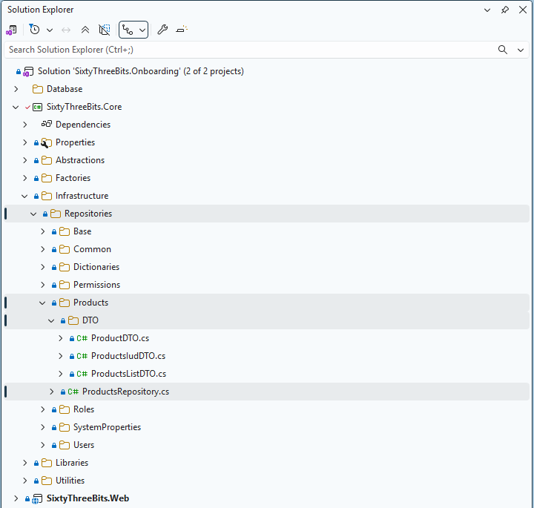

Repository Class
All repository classes must inherit from the RepositoryBase class.

Constructor
This inheritance requires two parameters to be passed through the constructor: DbContextFactory dbContextFactory and ILogger logger.
- DbContextFactory — A factory class developed by the 63BITS team, located in SixtyThreeBits.Core → Factories → DbContextFactory.cs. It is used to create an instance of DbContext within repository methods.
- ILogger — The standard interface from the Microsoft.Extensions.Logging namespace. It is used for logging exceptions thrown by the database.
Repository class example:
namespace SixtyThreeBits.Core.Infrastructure.Repositories
{
public class ProductsRepository : RepositoryBase
{
#region Constructors
public ProductsRepository(DbContextFactory dbContextFactory, ILogger logger) :
base(dbContextFactory, logger)
{
}
#endregion
}
}

Method Calling IUD Stored Procedure
The example below demonstrates how to write a method that calls the ProductsIUD stored procedure.
First, the ProductsIudDTO C# record must be created:
public record ProductsIudDTO
{
#region Properties
public string ProductName { get; init; }
public decimal? ProductPrice { get; init; }
public string ProductCoverImageFilename { get; init; }
public int? CategoryID { get; init; }
public bool? ProductIsPublished { get; init; }
#endregion
}

Note that bool? ProductIsPublished is defined as a nullable Boolean to support three distinct operational states:
- true – Set the product as published
- false – Set the product as unpublished
- null – Leave the current database value unchanged
This design allows the stored procedure to distinguish between explicitly updating the published status and omitting the update entirely.

Once ProductsIudDTO is ready, the method can be implemented:

public async Task<int?> ProductsIUD(DatabaseActions databaseAction, int? productID, ProductsIudDTO product)
{
var productJson = product.ToJson();

productID = await TryToReturnAsyncTask(
logString: $"{nameof(ProductsIUD)}({nameof(databaseAction)} = {databaseAction}, {nameof(productID)} = {product}, {nameof(productJson)} = {productJson})",
asyncFuncToTry: async () =>
{
using (var dbContext = _dbContextFactory.CreateDbContext())
{
var sqb = new SqlQueryBuilder(
dbContext: dbContext,
databaseObjectName: nameof(ProductsIUD),
sqlParameters:
[
databaseAction.ToSqlParameter(SqlDbType.TinyInt),
productID.ToSqlParameter(SqlDbType.Int),
productJson.ToSqlParameter(SqlDbType.NVarChar),
]
);

await sqb.ExecuteStoredProcedure();
productID = sqb.GetNextOutputParameterValue<int?>();
return productID;
}
}
);
return productID;
}

Code Breakdown
databaseAction parameter — An enum located at SixtyThreeBits.Core → Infrastructure → Repositories → Common → DatabaseActions.cs:
public enum DatabaseActions
{
#region Properties
INSERT = 0,
UPDATE = 1,
DELETE = 2,
#endregion
}

This enumeration is designed to match the first parameter, @databaseAction, of all SQL IUD stored procedures.

var productJson = product.ToJson(); — Declares a variable that converts the DTO to JSON. Its name also matches the corresponding stored procedure parameter.

productID = await TryToReturnAsyncTask — Calls the TryToReturnAsyncTask method to wrap the stored procedure call in a try/catch block and return the newly inserted (or already provided) productID.

logString — The first parameter of TryToReturnAsyncTask. Builds a string representing which method was called, what parameters were passed, and their values. If an exception occurs, this string is logged, which aids debugging by identifying the method, parameters, and values involved.

asyncFuncToTry — The second parameter of TryToReturnAsyncTask. An action delegate containing the code that must be wrapped in a try/catch block.

using (var dbContext = _dbContextFactory.CreateDbContext()) — Creates a dbContext via the _dbContextFactory received through the constructor.

var sqb = new SqlQueryBuilder(..) — Creates an instance of the SqlQueryBuilder class, developed by the 63BITS team and located at SixtyThreeBits.Core → Libraries → Database → SqlQueryBuilder.cs. This class is responsible for building and executing a proper SQL query. The dbContext, databaseObjectName (the stored procedure or function name), and sqlParameters are passed to its constructor to build the query.

await sqb.ExecuteStoredProcedure(); — Executes the stored procedure call against the database.

productID = sqb.GetNextOutputParameterValue<int?>(); — Retrieves the newly inserted ID from the database.

Method Calling a List (Table-Valued Function)
The example below demonstrates how to write a method that calls the ProductsList table-valued function to retrieve a collection of records.
First, the ProductsListDTO C# record must be created:
public record ProductsListDTO
{
#region Properties
public int? ProductID { get; init; }
public string ProductName { get; init; }
public decimal? ProductPrice { get; init; }
public string ProductCoverImageFilename { get; init; }
public int? CategoryID { get; init; }
public bool ProductIsPublished { get; init; }
public DateTime? ProductDateCreated { get; init; }
#endregion
}

Note that bool ProductIsPublished is not defined as a nullable Boolean. Because is this case product is either published or not. There is no third state.

Once ProductsListDTO is ready, the method can be implemented:
public async Task<List<ProductsListDTO>> ProductsList()
{
var result = await TryToReturnAsyncTask(
logString: $"{nameof(ProductsList)}()",
asyncFuncToTry: async () =>
{
using (var dbContext = _dbContextFactory.CreateDbContext())
{
var sqb = new SqlQueryBuilder(
dbContext: dbContext,
databaseObjectName: nameof(ProductsList)
);

var resultQueryable = sqb.ExecuteTableValuedFunction<ProductsListDTO>();
resultQueryable = resultQueryable.OrderByDescending(item => item.ProductDateCreated);
var result = await resultQueryable.ToListAsync();

return result;
}
}
);
return result;
}

Code Breakdown
The TryToReturnAsyncTask, logString, asyncFuncToTry, dbContext, and SqlQueryBuilder mechanics are identical to those described in Method Calling an IUD Stored Procedure. Only the differences specific to a list method are described below.

Task<List<ProductsListDTO>> return type — A list method returns a List<ProductsListDTO> containing every record produced by the table-valued function, rather than a single int?.

ProductsList() — no parameters — This method takes no parameters, so no DatabaseActions enum or DTO is passed, and the SqlQueryBuilder constructor receives no sqlParameters argument. Consequently, logString records the method name with empty parentheses: ProductsList().

var resultQueryable = sqb.ExecuteTableValuedFunction<ProductsListDTO>(); — Calls ExecuteTableValuedFunction to execute the function and return an IQueryable<ProductsListDTO>. The variable is explicitly named resultQueryable to make clear that the result is still an IQueryable — not yet materialized — so sorting and filtering can be composed before the query reaches the database.
This naming is mandatory.

resultQueryable = resultQueryable.OrderByDescending(item => item.ProductDateCreated); — Applies a descending sort by ProductDateCreated. As a deferred IQueryable operation, it is translated into SQL rather than executed in memory.

var result = await resultQueryable.ToListAsync(); — Materializes the query against the database. The materialized variable is explicitly named result to distinguish it from the queryable — result holds the executed List<ProductsListDTO>.
This naming is mandatory.

Method Calling a GetSingle (Scalar-Valued Function)
The example below demonstrates how to write a method that calls the ProductsGetSingleByID scalar-valued function to retrieve a single record by its ID.
First, the ProductDTO C# record must be created. Note that this DTO can contain nested records — here, ProductImages is a list of the nested ProductImage record — because the scalar-valued function returns a JSON string that can represent a full object graph:

public record ProductDTO
{
#region Properties
public int? ProductID { get; init; }
public string ProductName { get; init; }
public decimal? ProductPrice { get; init; }
public string ProductCoverImageFilename { get; init; }
public bool ProductIsPublished { get; init; }
public DateTime? ProductDateCreated { get; init; }
public int? CategoryID { get; init; }
public string CategoryName { get; init; }
public List<ProductImage> ProductImages { get; init; }
#endregion

#region Nested Classes
public record ProductImage
{
#region Properties
public int? ProductImageID { get; init; }
public string ProductImageFilename { get; init; }
#endregion
}
#endregion
}

Note that bool ProductIsPublished is not defined as a nullable Boolean. Because is this case product is either published or not. There is no third state.

Once ProductDTO is ready, the method can be implemented:
public async Task<ProductDTO> ProductsGetSingleByID(int? productID)
{
var result = await TryToReturnAsyncTask(
logString: $"{nameof(ProductsGetSingleByID)}({nameof(productID)} = {productID})",
asyncFuncToTry: async () =>
{
using (var dbContext = _dbContextFactory.CreateDbContext())
{
var sqb = new SqlQueryBuilder(
dbContext: dbContext,
databaseObjectName: nameof(ProductsGetSingleByID),
sqlParameters:
[
productID.ToSqlParameter(SqlDbType.Int)
]
);

var resultJson = await sqb.ExecuteScalarValuedFunction<string>();
var result = resultJson.DeserializeJsonTo<ProductDTO>();
return result;
}
}
);
return result;
}

Code Breakdown
The TryToReturnAsyncTask, logString, asyncFuncToTry, dbContext, and SqlQueryBuilder mechanics are identical to those described in Method Calling an IUD Stored Procedure. Only the differences specific to a get-single method are described below.

Task<ProductDTO> return type — A get-single method returns a single ProductDTO object.

ProductsGetSingleByID(int? productID) — Takes the productID as a parameter, which is passed to the SqlQueryBuilder as a single sqlParameter.

var resultJson = await sqb.ExecuteScalarValuedFunction<string>(); — Calls ExecuteScalarValuedFunction to execute the scalar-valued function. The function returns a single scalar value — a JSON string representing the full object graph — which is captured in resultJson. The variable is explicitly named resultJson to make clear that the result a JSON STRING.
This naming is mandatory.

var result = resultJson.DeserializeJsonTo<ProductDTO>(); — Deserializes the returned JSON string into a ProductDTO instance, including any nested records such as ProductImages.
The deserialized variable is explicitly named result to distinguish it from the JSON String.
This naming is mandatory.

Registering the Repository in the Factory
To wrap everything up, the ProductsRepository must be registered in the RepositoryFactory. This allows other layers to create repository instances as needed.
RepositoryFactory is a class developed by the 63BITS team, located at SixtyThreeBits.Core → Factories → RepositoryFactory.cs. It is responsible for creating repository instances.
A new method must be added to this class:
public ProductsRepository CreateProductsRepository()
{
return new ProductsRepository(_dbContextFactory, _logger);
}

